**Output Files:**

Q.2.

A. Write a python program to perform the following operations on complex numbers by

creating a class complex_number. Create two objects c1 and c2.

a. Addition

b. Subtraction

c. Multiplication

d. Check if two complex numbers are equal or not

e. Check if c1>=c2

f. Check if c1==c2Perform these operations using operator overloading in python.

**Output:**

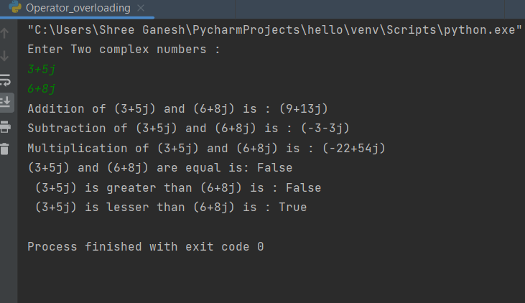

B. Define a class person (attributes: name, department, date Of Birth). Derive two classes employee (attributes: employee id, salary) and student (attributes: PRN, year, CGPA) from person class. Derive two classes lab_assistant (attributes: labs) and faculty (attributes: subject, number of research papers, qualification).

i) Create objects for lab assistant, faculties, and students.

ii) Display the data.

iii) Delete a data

iv) Find the total salary of all employees.

v) Find average CGPA of students department wise.

**Output:**

